AWS Pulsar Standalone AMI User Documentation

Launch AMI:
Follow the steps below to launch the Pulsar Standalone AMI from your AWS account:
- Navigate to AWS Marketplace in your account
- In the left-hand panel, select Manage Subscriptions
- Click on the Pulsar Standalone product from your list of subscriptions
- In the upper right-hand corner, click Launch new instance
- Ensure the latest software version is selected (this is the default)
- Choose your preferred AWS region from the region dropdown menu
- Click Continue to launch through EC2

Configure EC2 Instance:
Follow the steps below to configure your EC2 instance before launch:
- Name and Tags:
  - Label your instance with your preferred name for easy identification
- Application and OS Images (Amazon Machine Image)
  - This AMI is already selected for you – leave unchanged (default)
- Instance Type:
  - Leave as the default: t2.large
    - Note: This is the minimum instance size recommended for optimal performance and to avoid errors or resource limitations
- Key Pair (login):
  - Select an existing keypair from the dropdown menu if available, or follow the below steps to create a new one:
    - Click Create new key pair within the key pair login section
    - Enter your preferred key pair name
    - Key pair type: RSA
    - Private key file format: .pem
    - Click Create key pair
      - Your new key pair file will automatically download to your browser
      - Move the key pair to your preferred secure location
- Network Settings:
  - Note: If you already have a security group configured for use with this AMI, click Select existing security group and choose it from the Common Security Groups dropdown.
  - If you do not yet have an appropriate security group, follow the below steps:
    - Click edit in the right-hand corner of the Network Settings section
      - VPC: leave as default
      - Subnet: leave as default (no preference)
      - Auto-assign public IP: leave as default (enabled)
      - Firewall: Select the Create security group option
        - Security group name: leave as auto generated or enter a preferred name
        - Description: leave as auto generated or enter a preferred description
        - Inbound Security Group Rules: Create the following inbound rules as shown in the screenshot below:
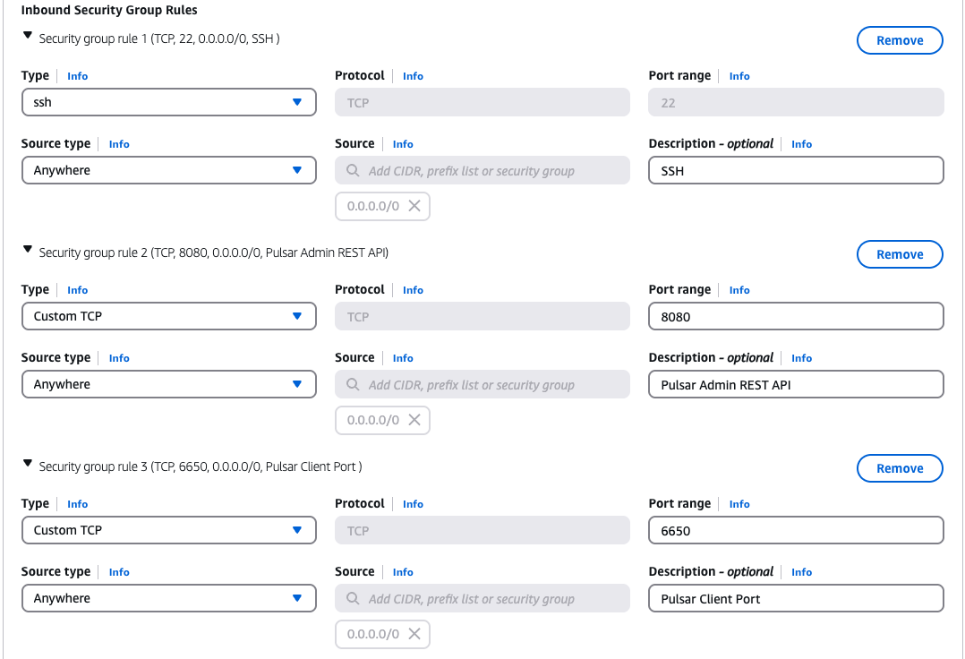
- Configure Storage:
  - Leave as default
- Advanced Details:
  - Leave as default

Launch EC2 Instance:
Once you’ve completed the configuration steps above, follow the below instructions to launch your instance:
- Click Launch Instance in the lower-right corner of the page
Your instance is now booting up!
- You can view your instance by navigating to EC2 -> Instances in the AWS Console
- Wait until the Instance State shows “Running” and the Status Check is marked as complete
Once both indicators are green, you’re ready to move on to next steps

Access EC2 Instance as ec2-user:
To connect to your EC2 instance via SSH:
- Navigate to EC2 -> Instances and select your instance from the list
- In the Details pane, copy the Public IPv4 address
  - Note: You’ll use this address in the SSH command below
- Open a terminal on your local machine
- Navigate to the directory where you saved your key pair file
  - Example: `cd ~/Desktop`
- Set permissions on the key pair file:
  - `chmod 400 <key_pair_name>.pem`
- Log in to your instance using the below SSH command:
  - `ssh -i <key_pair_name>.pem ec2-user@<instance_ipv4_address>`
You should now be logged into your instance as ec2-user

Test Pulsar Standalone Container:
Now that you’re logged into your EC2 instance, which is running the Pulsar Standalone Docker container, you can test it using the provided test scripts. Follow the below steps to see how they work:
- Open a second terminal tab or window on your local machine
- Log in to the EC2 instance in the new terminal tab using the same SSH command you used earlier
- In both terminals, navigate to the test scripts directory:
  - `cd pulsar-test-scripts`
- In the first terminal, start the pulsar consumer:
  - `python3 pulsar_consumer.py`
- In the second terminal, start the pulsar producer
  - `python3 pulsar_producer.py`
The producer will quickly send 100 sample messages to the consumer.
In the consumer terminal, you should see output confirming each message was received, along with their message IDs
- Still using the producer terminal, you can now test with an infinite producer (while keeping the consumer running):
  - `python3 infinite_producer.py`
You should now see the producer continuously sending messages, while the consumer continues receiving them in real-time
- When you are finished observing the message flow, stop both scripts by pressing Ctrl+C in each terminal

Experiment with Pulsar Standalone:
You’ve successfully accessed, run, and tested your Pulsar Standalone container. Now you're ready to begin developing and experimenting with Apache Pulsar using the running standalone cluster.
To dive deeper into Pulsar functionality, refer to the Apache Pulsar Official Latest Documentation
- Note: Since this AMI launches the Pulsar Standalone automatically, you can skip the “Getting Started” steps in the official documentation

Access the Pulsar Container
To run Pulsar CLI commands or make configuration changes, you'll need to work inside the Docker container.
- Use the following command to enter the container as the root user:
  - `docker exec -it -u root pulsar-standalone bash`
From there, you can follow along with the official Pulsar docs to explore the following features:
- Creating topics
- Managing tenants and namespaces
- Experimenting with the Pulsar CLI tool
- Testing performance
- and much more!
Happy experimenting!

Common Troubleshooting Tips:

SSH Login Issues:
- Problem: Unable to login to your EC2 instance via SSH
- Solutions:
  - Ensure you are using the correct key pair you download during instance configuration
    - Make sure the key file has the correct permissions:
      - `chmod 400 <key_pair_name>.pem`
  - Ensure you are logging in to your instance as ec2-user
  - Verify your EC2 security group allows inbound SSH (port 22) traffic from your IP address or from anywhere (0.0.0.0/0) for testing.

Pulsar Connectivity Issues:
- Problem: The Pulsar Standalone container is not running, cannot be accessed, or test scripts fail to connect to the broker
- Solutions:
  - Check the container status:
    - `docker ps -a`
    - If the status says stopped, start the container again:
      - `docker container start pulsar-standalone`
    - If the status says exited, restart the container:
      - `docker container restart pulsar-standalone`
    - If the container fails to start/restart, examine the container logs:
      - `docker logs pulsar standalone`
  - Verify your EC2 instance security group has the correct inbound rules:
    - Port 22 for SSH access
    - Port 6650 for Pulsar client connections
    - Port 8080 for the Pulsar web interface
  - If you are trying to send traffic outbound (e.g., to another service or broker), confirm outbound rules allow it:
    - Allow all traffic to 0.0.0.0/0 or add specific IP/port rules as needed

Pulsar CLI Access Denied:
- Problem: Access denied when running `pulsar-admin` or other Pulsar CLI commands
- Solutions:
  - Ensure you are inside the container as the root user:
    - `docker exec -it -u root pulsar-standalone bash`
  - Confirm that the command you are running is valid by referring to Apache Pulsar CLI Documentation

High Resource Utilization/Performance Issues:
- Problem: The EC2 instance is slow or experiencing high CPU/RAM usage
- Solutions:
  - Open the AWS CloudWatch dashboard to view your instance's performance metrics. Check for high CPU utilization, memory pressure, or disk I/O bottlenecks.
  - If resource usage is consistently high:
    - Consider stopping the instance and changing the instance type to a larger size (e.g., t2.large, t3.large, or higher) to better support your workload.
  - Avoid running multiple heavy tasks simultaneously unless using an instance with sufficient resources

Cleanup:
After you are finished using the Pulsar Standalone AMI or service, it’s important to clean up your AWS resources and any running processes inside the instance. This helps avoid unnecessary charges and ensures your environment stays clean.

Pulsar:
- If your test scripts are still running, stop them by pressing Ctrl+C in both the producer and consumer terminal windows.
- If you would like to stop or remove the pulsar container temporarily:
  - Stop: `docker container stop pulsar-standalone`
  - Remove: `docker rm pulsar-standalone`
Note: On instance reboot or startup, the Pulsar Standalone container will automatically restart, and your previous Pulsar data (tenants, topics, namespaces, messages, etc.) will be restored via Docker volumes.
- If you want a fresh Pulsar instance with no previously saved data, you can either:
  - Launch a new EC2 instance from the Pulsar AMI, or
  - Stop and remove the container along with its volumes, then reboot:
    - `docker container stop pulsar-standalone`
    - `docker rm -v pulsar-standalone`
    - `sudo reboot`
  - After rebooting and logging back in, a new Pulsar Standalone container will be initialized without any of the old data.

EC2 Instance:
- Remember to stop or terminate your Pulsar Standalone EC2 instance when it’s not in use to avoid incurring charges:
  - Navigate to EC2 -> Instances
  - Select your instance
  - Go to Instance State and choose:
    - stop – pauses the instance (temporary)
    - terminate – deletes the instance permanently (irreversible)

Additional Resources:

Pulsar Community:
- For questions, discussions, or community support, visit the Apache Pulsar Community Resources page

Pulsar Standalone Service Support:
- For general inquiries or issues related to the Pulsar Standalone service or this documentation, please contact: support@evlos.tech

AWS Marketplace:
- For questions related to the AMI or AWS Marketplace usage, please consult the AWS Marketplace Documentation.

